Mahatma Education Society’s

**Pillai College of Arts, Commerce & Science**

# (Autonomous)

**Affiliated to University of Mumbai**

NAAC Accredited 'A' grade (3 cycles) Best College Award by University of Mumbai

ISO 9001:2015 Certified

**CERTIFICATE**

*This is to certify that Miss.* ***Alice Narendra Durge*** *of*

***F.Y B.Sc. C.S. Semester II*** *has completed the project work in the Subject of* ***Python Programming*** *during the academic year 2021-22 under the guidance of Prof****. Jabeen Masum*** *being the partial requirement for the fulfillment of the curriculum of* ***Degree of Bachelor of Science in Computer Science****,* ***University of Mumbai****.*

***Place:***

***Date:***

*Name & Signature of faculty Name & Signature of external*

TOPIC OF THE

PYTHON PROJECT: TIC TAC TOE GAME .

**INTRODUCTION:**

In this project , the game of tic tac toe is built using the python programming language. Due to portable and extendable nature of python , it was easy to design the game . There is usage of loops,conditional statements as well as functions.

So , in short , python can be used to develop any kind of game or application based software.

**CODE:**

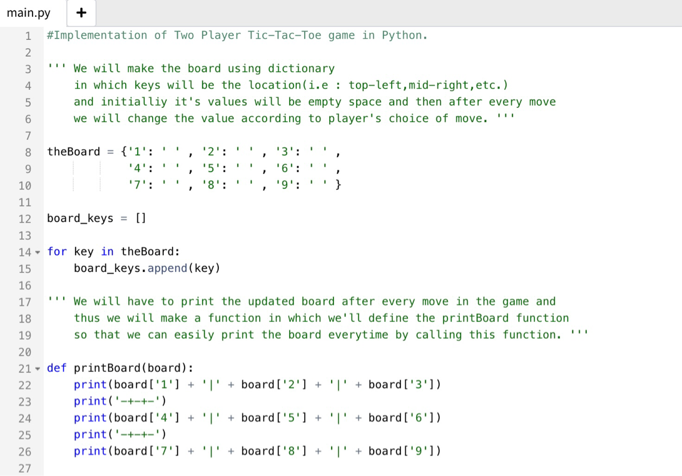

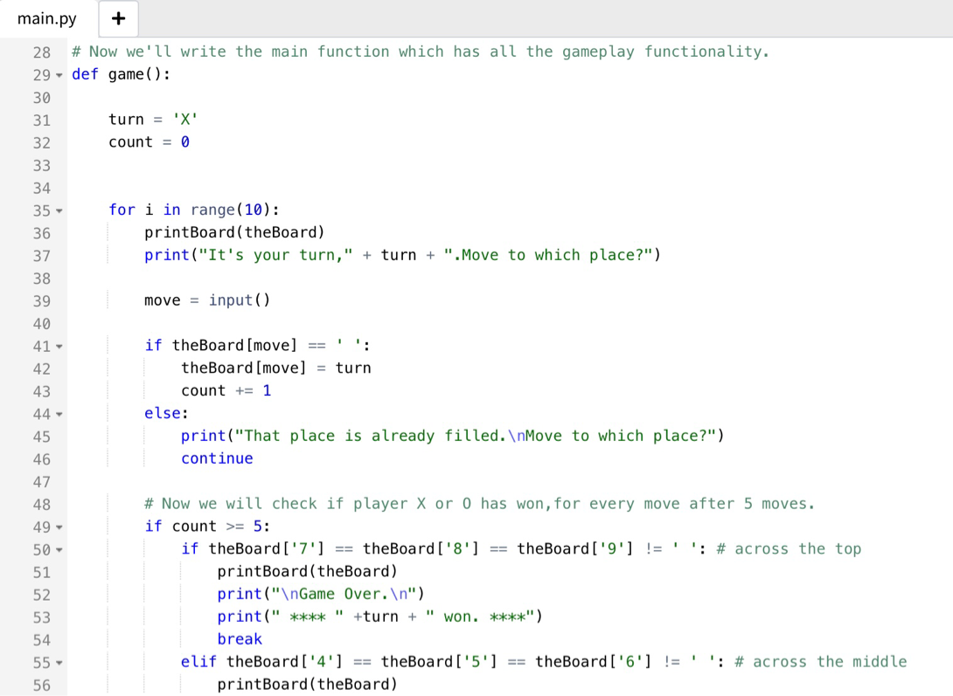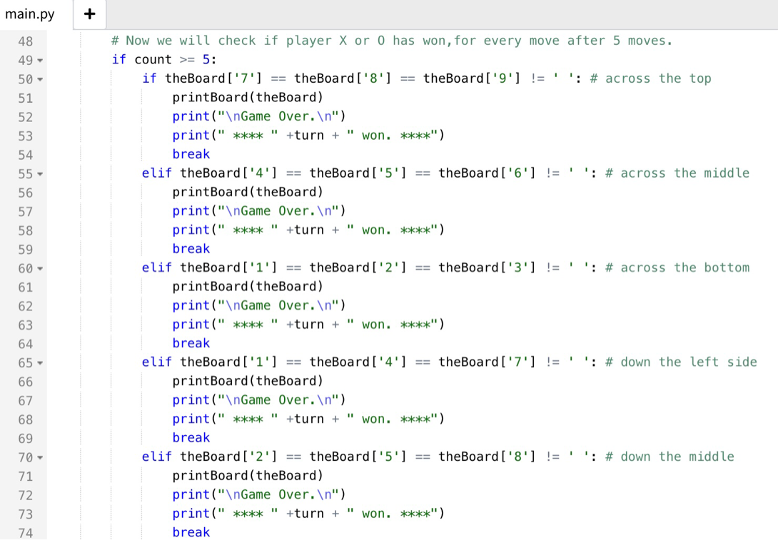

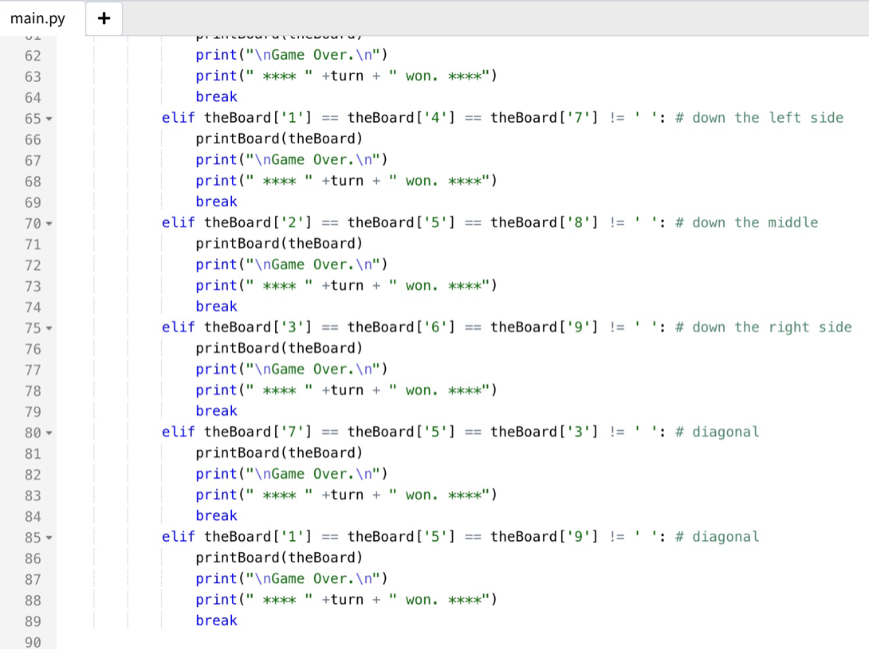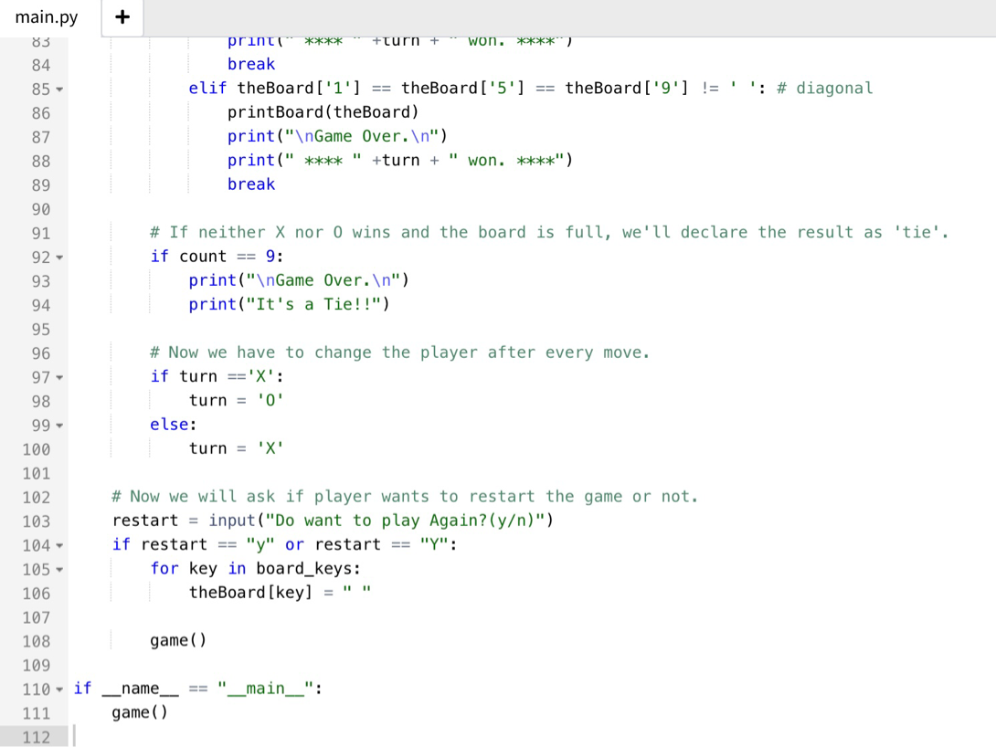

**Output:**

